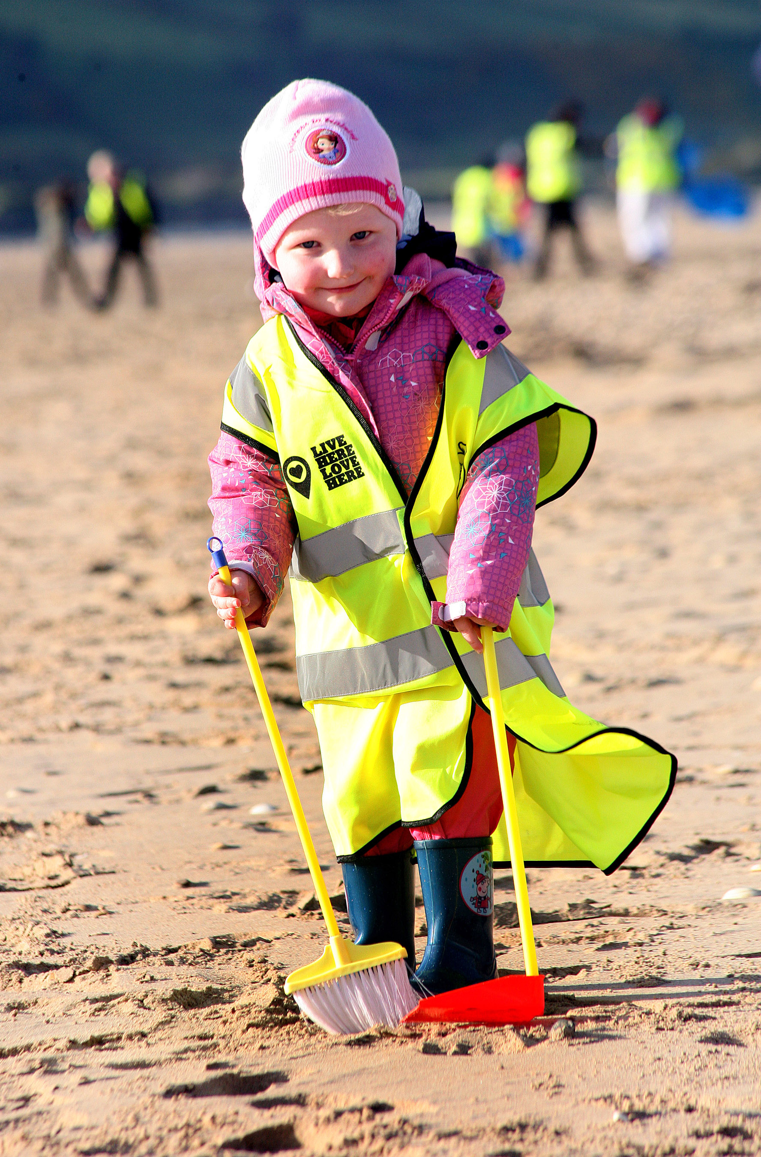

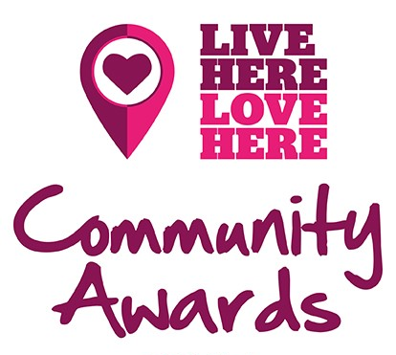

Application Pack

2019

Help with your application

HOW TO ENTER.
Group and/or individual nominations must be made by completing the attached nomination form and forwarding as directed below. Please fill in as much detail as possible to give your group or your nominee the best possible chance of being selected. The deadline for all entries is 12 noon Monday 7th January 2019.

NUMBER OF GROUP and/or INDIVIDUAL NOMINATIONS.
Group and/or individual nominations can be made for as many awards as you wish. These awards are to reward groups and individuals carrying out environmental improvement activities in a voluntary capacity. Please remember volunteers come in many forms; don’t forget the management committee or someone who may not formally volunteer regularly, but is always there when you need them.

HOW YOUR ENTRY WILL BE ASSESSED.
The Live Here Love Here Community Awards will be judged by a panel of independent judges with relevant experience in community development and the environmental sectors as well as a representative from event sponsors. All nominations will be examined carefully by the judging panel and judge’s decision is final. Please note that unfortunately due to time and resource constraints, feedback on unsuccessful applications will not be provided.

WHEN YOU WILL FIND OUT IF YOU HAVE BEEN SUCCESSFUL.
Shortlisted nominees will be notified in January 2019 and will be invited to attend the gala dinner awards evening, taking place in Belfast City Hall on Tuesday 12th February 2019.

PRIZES
All award winners will receive a commemorative award in recognition of their efforts plus a framed certificate. Winners will also receive a prize worth £100.

TERMS & CONDITIONS
1. These awards are open to open to volunteers involved in projects in Northern Ireland.
2. Nominated groups or individuals must be working within a voluntary capacity.
3. Employees of Keep Northern Ireland Beautiful, supporting councils, DAERA, Coca-Cola HBC NI, McDonald’s, Northern Ireland Housing Executive, and Choice Housing are not eligible to receive awards.
4. The winners’ names and photographs of the award winners at the ceremony will be published on www.liveherelovehere.org and social media channels after the awards. A press release and images will also be circulated to local and national press.
5. The above information is correct although the organisers reserve the right to change any of the above without prior notice.
6. Any breach by the entrant of the above terms and conditions will render their entry invalid. If a breach has occurred but is discovered after the award of a prize then the organisers may request the return of the prize.
7. A selected panel of independent judges assess all entries and shortlisted will be contacted following the closing date. All judges’ decisions are final and no discussion will be entered into on these decisions.
8. Entrants must affirm that they have complied with all local and national regulations pertaining to protection of vulnerable habitats, places and activities.
9. Unfortunately due to the high number of entries, feedback will not be provided to unsuccessful applicants.
10. If shortlisted, the nominee will be contacted in the first instance. If contact cannot be made with the nominee, the nominator will be notified.

PLEASE RETURN ALL COMPLETED ENTRIES BY EMAIL TO
Karina Robinson at karina.robinson@keepnorthernirelandbeautiful.org

OR SEND TO
Live Here Love Here, Bridge House, 2 Paulett Avenue, Belfast, BT5 4HD

AWARD CATEGORIES

Please read the criteria below carefully to determine whether your group and/or an individual you know could be nominated for an award. Minimum requirements: All nominees must make an effort to build civic pride in their area on a voluntary capacity, tackling issues such as littering and dog fouling or by improving dilapidated and/ or neglected green space.

The Litter Heroes Awards:

To recognise a group or individual who has shown a dedication to Live Here Love Here in their supporting council area. They have demonstrated consistent hard work, instilling civic pride and tackling environmental issues. These awards are specifically open to any individual, group, school, business or sporting association working in a voluntary capacity within a supporting council area:

Antrim and Newtownabbey Litter Heroes Award

Ards and North Down Litter Heroes Award

Armagh City, Banbridge and Craigavon Litter Heroes Award

Belfast City Litter Heroes Award

Derry City and Strabane Litter Heroes Award

Fermanagh and Omagh Litter Heroes Award

Lisburn and Castlereagh City Litter Heroes Award

Mid and East Antrim Litter Heroes Award

Mid Ulster Litter Heroes Award

Newry, Mourne and Down Litter Heroes Award

The following awards categories are open to any individual, group, school, business or sporting association working in a voluntary capacity within any council area and/or any area managed by Northern Ireland Housing Executive or a Housing Association:

Adopt A Spot Award presented by Keep Northern Ireland Beautiful

This award recognises any efforts which have made a substantial contribution to the Adopt A Spot Programme. Novel, original and presents Adopt A Spot from a new/untried angle.

Good Neighbour Award presented by Choice Housing

This award recognises any outstanding contribution to developing the local community through green ups, clean ups and spruce ups.

Community Together Award presented by Northern Ireland Housing Executive

This award recognises any significant efforts to overcome barriers of community division in order to promote good community relations through practical environmental action.

Coast Care Award presented by Coca-Cola HBC
(12 years old and over only eligible for award)

This award recognises the work of a group or individual who has made a significant effort to raise awareness and/or reduce litter through practical action to protect our coastal or inland waterway environment.

The BIG Transformation Award presented by McDonald’s
(16 years old and over only eligible for award)

This award recognises a significant transformation to an open/public space which showcases environmental stewardship and community engagement.

Spirit of Live Here Love Here Award presented by DAERA

This award recognises the work of a group/ individual who has broken the boundaries of ‘normal’ clean ups and community engagement. It recognises an individual who has demonstrated ongoing commitment to Live Here Love Here through consistent hard work in the form of clean-ups or other activities. They have gone above and beyond the expectations and embody the message of Live Here Love Here through their work.

Contact us
Email: enquiries@liveherelovehere.org
Phone: 02890 736920
Website: www.liveherelovehere.org

Celebrating 5 years of Live Here Love Here
@liveherelovehere
@isuppportlhlh

@livehere.lovehere

#liveherelovehere #LHLHAwards19 #litterheroes







