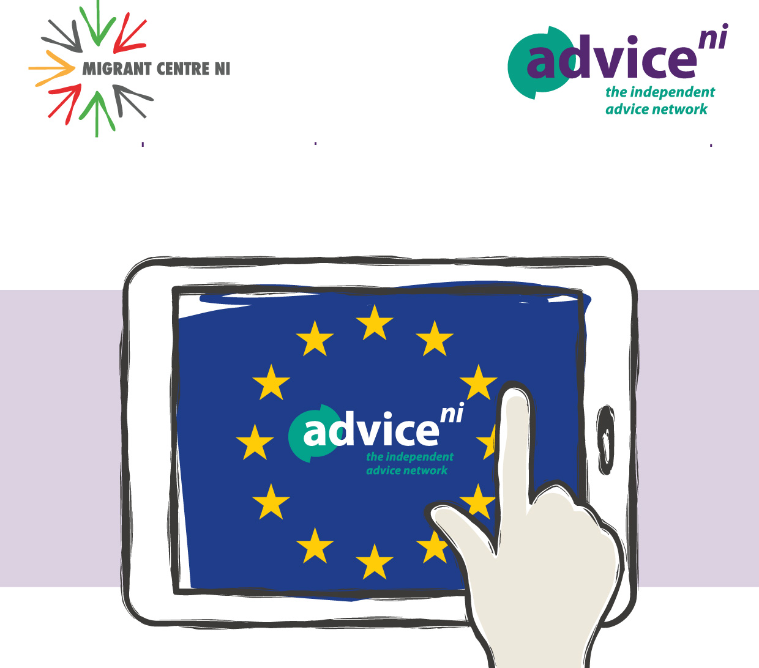
Order Form
EU Settlement Scheme Poster Request Form

Please state below where you would like these posters delivered to, giving the full postal address and a contact name.

Delivery Details

Name  Organisation: | ___________________________________________________________
Address:

Postcode:

 | Quantity (please tick)
A4 Poster  A6 postcards  Posters/postcards can be supplied in different languages, please get in touch if you require a different language/s | 5 10  5 10  Please state quantity __________
Tel: 028 90 645919
Post: Advice NI
1 Rushfield Avenue, Belfast, BT7 3FP
Email: elkie@adviceni.net

Send your order
via email to
Advice NI

