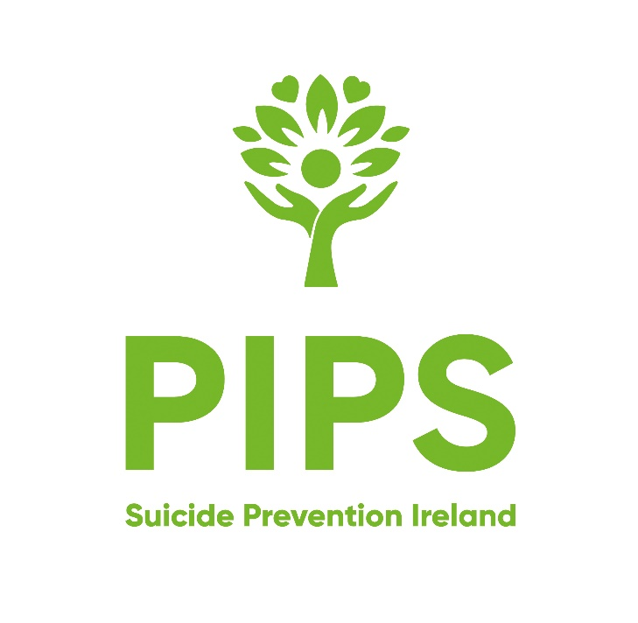

JOB DESCRIPTION

JOB TITLE: Befriender
BASED AT: Roving (Various Locations throughout NI)
HOURS OF WORK: 23 hours /week (flexible) including evenings and weekends
REPORTS TO Care team Manager - Befriending and Advocacy
SALARY £11.46
EMPLOYMENT STATUS: 1 year fixed Contract with potential for extension to 2 years
HOLIDAYS: 39 days (Pro Rata)
PROBATIONARY PERIOD: 6 months
PENSION: PIPS is a member of NEST Pension Scheme. The scheme is open to all employees aged between 22 and state pension age.

NOTICE PERIOD: 1 month
Additional: The post holder is required to have access to a car, with appropriate Business Insurance

FUNCTION

This Befriender role entails meeting with and befriending people within Starbucks Stores.
The aim of the role is to meet and befriend staff and customers who feel isolated or who are living with poor mental health.

PIPS Vision Statement
Striving for a compassionate Society free from suicide

PIPS Mission Statement
We help individuals, families and organisations who have been affected by suicide or mental un-wellness and we do this by:
• Providing support and counselling services in an accessible and non-judgmental space for individuals to understand themselves and to better navigate their personal path in life
• Providing a neutral, compassionate and supportive environment by offering a space for peer groups to share their experiences of emotional challenges
• Working with organisations to nurture a culture of awareness and understanding of mental wellness, by providing specialist training and volunteering opportunities
• Working with local communities and government bodies to influence societal change with the aim to advance the understanding of suicide and mental wellness within Ireland
PIPS Values
- We value active and non-judgemental listening to fully understand the needs of our clients and Stakeholders, to promote positive change.
- We value engaging with our clients and Stakeholders in a compassionate and empathetic manner, to deepen connections and support transformational change.
- We value the ability to be adaptable and flexible in an ever changing world, moving quickly and decisively.
- We value respect by accepting each individual for who they are which enables us to build strong relationships based on trust and safety.
- We value confidentiality as the foundation of maintaining trusting relationships with our Stakeholders, by handling all information with the utmost care, privacy and in keeping with ethical boundaries.
- We value our courage to do the right thing, influence societal change, by challenging the status quo and transforming our communities.
- We value our Commitment to Excellence in promoting mental wellness by maintaining the highest standards, by continually learning, improving and innovating.
- We value integrity as the fundamental basis of how we operate, by consistently behaving in a moral, ethical, transparent, accountable and honest manner.
- We value self-determination where individuals have the right to make their own decisions and choices, so that they become active participants in their own journey.

MAIN RESPONSIBILITIES

- To attend the store and meet with those people who could benefit from Befriending.
- To spend 8 hours on average per week visiting the Starbucks stores.
- To communicate effectively and sensitively with people on a one-to-one basis or in groups.
- To maintain absolute integrity and confidentiality in relation to personal issues raised by befriending service users
- To ensure administration systems are adhered to and records are produced as required
- To ensure the implementation of PIPS Charity policies.
- Participate in appropriate training as directed by the Careteam Manager.
- To adopt a proactive approach in promoting PIPS Charity and any activities relating to their programmes and services.
- To adopt a flexible approach to working hours of duty.
- To ensure all administration is carried out in a timely manner and report changes at all times.
- To undertake any other duties which may be reasonably requested.
- To undergo AccessNI check at enhanced level.

N.B. This job description is not definitive or restrictive and may be modified to meet the changing needs of PIPS Charity.

Other Duties
The duties and responsibilities of this job description are neither definitive or restrictive and can be modified to meet the changing needs of the organisation. You will be required on occasions to contribute flexibly across the work of PIPS, performing duties in other areas of work commensurate with the role as required. The organisation is committed to providing the highest possible quality of service to its clients and the community. Members of staff are always expected to provide a caring service and to treat those with whom they come into contact in a courteous and respectful manner.

PERSONAL SPECIFICATION

POST: Befriender

LOCATION: Various Starbucks Stores across N.I.

ESSENTIAL CRITERIA

- A minimum of one years’ Counselling experience

- Be of a kind and caring nature with a high degree of genuineness and empathy for people with poor mental health.

- Demonstrate excellent interpersonal skills, with the ability to listen & communicate effectively.

- Demonstrate a non-judgemental approach and a good understanding of person-centred support delivery.

- Be passionate about supporting people with mental health issues and have practical understanding of issues affecting them.

- Be honest, reliable, adaptable, and can work within boundaries.

- Have a mature attitude and apply common sense approaches within the befriending prole.

- Demonstrate sound judgement with the ability to work independently and on own initiative.

- Demonstrate excellent communication skills including use of IT systems and the ability to work to deadlines.

- Good record keeping

DESIRABLE CRITERIA

- Previous Befriending Experience

PIPS Charity is aware that some persons with disabilities may not be able to hold a driving licence. If this is the case, please demonstrate how you can fulfil the mobility requirements for the post for which you are applying.

