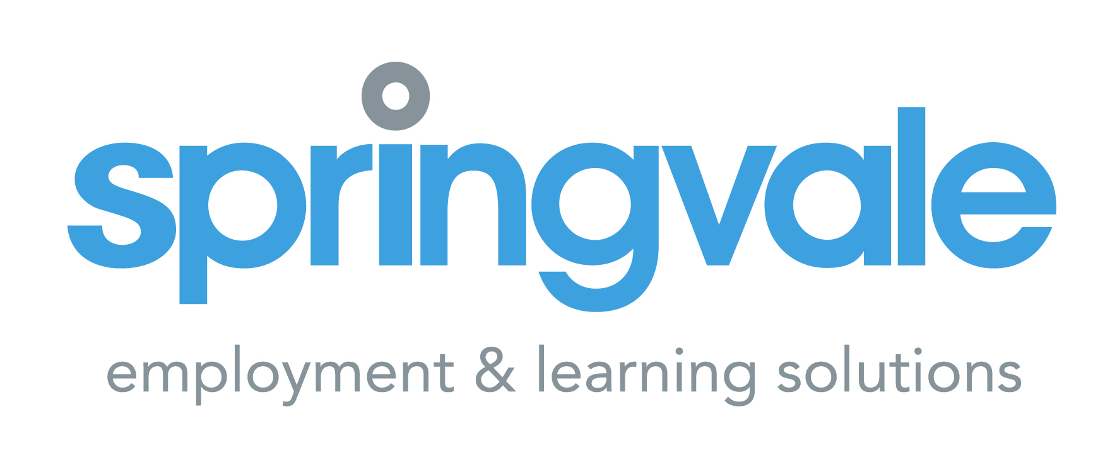

Job Description

Post: YouthStart Mentor

Responsible to: Project Co-Ordinator

Hours: 37 per week

Location: 200 Springfield Road, Belfast, BT12 7DB

Salary: £29,269

Contract Term: Contract to the 31st March 2025 (with possible extension subject to funding)

Main Purpose
Provide a person-centred employability programme including mentoring and groupwork targeting those furthest from the labour market and aimed at removing barriers to employment and supporting young people into employment. The employability work coach will be responsible for engaging young people 16-24 years not in education, training or employment, undertake one-to-one mentoring and group support to remove barriers, facilitating their progress into employment, training or education.

Principal Duties

- Engage young people 16-24 years who are not in education, training or employment onto the Youthstart programme - using in-house referrals, grass roots marketing and through local infrastructure. This shall include working closely and developing excellent working relationships with community, statutory and voluntary organisations within the area. This will be measured through set targets (including targets for continued engagement, qualifications obtained and into employment) and formally reviewed.

- Undertake initial assessments of barriers to employment and registrations completed with assessment and diagnostic tools including an employability barriers checklist. Assessment uncovers existing achievements, skills and strengths, interests and goals as well as barriers such as disability, essential skills, structural barriers, work experience and work-related issues, personal circumstances, debt and benefits issues, learning experience, mobility, childcare needs, convictions, housing issues, drug and alcohol misuse, health and wellbeing, confidence, motivation and self esteem.

- Develop and implement individual action plans to overcome barriers: outlining goals, actions and outcomes. This to include one-to-one mentoring and group sessions, outdoor activities, providing a safe, relaxing environment underpinned by a community development approach within a structured and developmental process.

- Undertake outreach mentoring within the community that best suits the needs of young people.

- Build peoples self-esteem, self-confidence, motivation, resilience, and employability skills through the mentoring process.

- Referral to specialist agencies where required to remove specific barriers to education, training and/or employment.

- Provide support for young people on the programme and act as a point of contact. This will involve undertaking mentoring to meet participants’ needs.

- Assist the project manager design programmes, ensuring young people attend training, undertaking mentoring, groupwork and organising community-based projects to meet the needs of participants.

- In partnership with the young person, to agree progression plans prior to completion of the programme which will include consideration of all the options open to the young people and an exploration of next steps and progression pathways.

- Monitor and track individuals, providing up to date information/reports on progress and issues relating to individual caseload. This shall include the accurate and timely completion of appropriate forms for caseloading and continual engagement, tracking and reviewing personal action plans etc.

- Provide aftercare support, tracking and reviewing young people’s progression in employment, education, or training.

- Develop forward job plan for the post and achieve targets and produce monthly reports on activity/outcomes as required.

- Undertake staff development activities that shall enhance individual, team, and organisational performance.

- Undertake regular, formal supervision with Project Co-ordinator to measure performance targets and reflect on practice.

- Attend and participate in team meetings.

- Any other reasonable duties assigned by Springvale

The concept of team working means that a flexible approach to work areas is required from the postholder. The work areas identified above are not exhaustive and only represent current principal tasks. The post holder may therefore be required to carry out other duties as determined by Springvale from time to time.

Personnel Specification

The personnel specification shows essential skills, abilities, knowledge and/or qualifications required to be able to perform the duties of this post. Please therefore address, in completing the application form, each criterion listed in the specification, drawing upon all your experience, whether at work or on a voluntary basis.

It is essential that candidates clearly outline on their application how they meet each of the following criteria. Only those candidates that do so will be shortlisted.

Proven Competence/Educational Attainments:  - A proven competence of two years working within the field of youth work, education, training, or employability  - At least two years’ proven competence in delivering innovate programmes that directly meet the needs of young people 16-24 years old (either group-work or mentoring)  - Relevant qualification such as Advice & Guidance Level 2 or equivalent | Essential  Essential  Essential
We also welcome candidates who can demonstrate aspects of advice and guidance within their
qualifications. Areas considered are: careers guidance, recruitment, counselling, youth work,
coaching, teaching, customer service, social work and training. At least one year’s proven
competence in providing career/employability guidance in both a one-to-one and/or group
setting. In addition, will work towards and complete NVQ Level 3 in Advice and Guidance during
their first 6 months in post.
Or
- Candidates who can demonstrate competence in providing advice and guidance in particular career/employment guidance as part of 2 or more years work experience within a careers guidance, recruitment, counselling, youth work, coaching, teaching, customer service, social work and training. In addition, will work towards and complete NVQ Level 3 in Advice and Guidance during their first 6 months in post.

Skills/Abilities:  - Excellent written and oral communication skills at all levels  - Sound knowledge of ICT  - Motivating others  - Working positively within a team  - Using own initiative | Essential  Essential  Essential  Essential  Essential
Knowledge:  - Current issues for young people within a disadvantaged community  - An understanding of employability, education and training pathways and models of mentoring | Essential  Essential
Circumstances:  - Ability to work flexible hours  - Willingness to undertake training required for the post  - Subject to Access NI enhanced with barred checklist for children clearance. | Essential  Essential  Essential

PACKAGE:

- Competitive salary package
- Mileage: 45p per mile
- 20 days holiday rising with length of service
- 10 statutory holidays per year
- Access to childcare vouchers if applicable
- Company pension

We reserve the right to apply further criteria to facilitate effective short-listing in the event of a high number of applications

Springvale is an Equal Opportunities Employer

