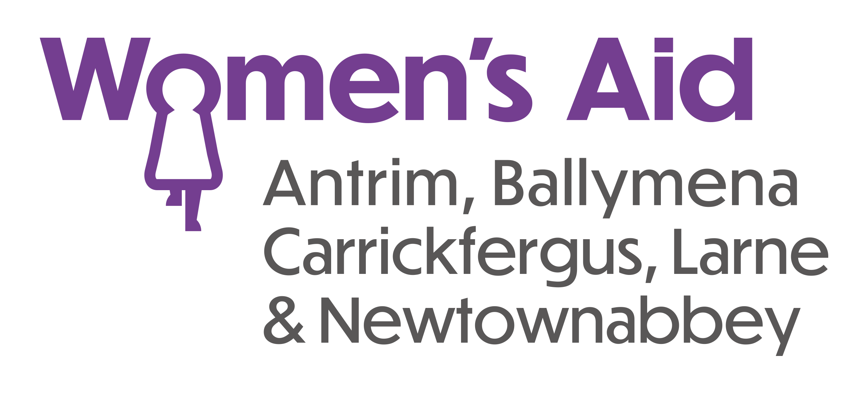

VOLUNTEER APPLICATION FORM

Name:

Address:

Telephone No:

Email address:

Occupation (if applicable):

Do you drive and have access to a car?

Have you used any domestic abuse support services within the past year? Yes/No
(Please note this is confidential.)

Tell us why you would you like to volunteer with Women’s Aid ABCLN?

Tell us about any relevant skills and experience you may have.

Tell us what volunteer roles and activities you are interested in

Is there any reason why you cannot work with vulnerable adults or children?

All volunteers will be asked to complete Access NI check. You will be asked to declare if you have any convictions that are not “protected” as defined by the Rehabilitation of Offenders (Exceptions) (NI) Order 1979, as amended in 2014. This information will only be seen by nominated officers. A copy of the Access NI Code of Practice is available on request.

Do you have any convictions that are not “protected” as defined by the Rehabilitation of Offenders (Exceptions) (Northern Ireland) Order 1979, as amended in 2014?
If yes, please give details:

Women’s Aid ABCLN has a policy on the recruitment of ex-offenders. Please note disclosure of a conviction does not necessarily debar any applicant from becoming a volunteer.

Do you have any accessibility or support needs you would like to share with us?

Please nominate two referees who have known you for at least two years:

Reference 1
Name:
Email address:
Address:
Telephone:
How do they know you?

Reference 2
Name:
Email address:
Address:
Telephone:
How do they know you?

Please return your Volunteer Application by email or post to the address below.

By email: volunteering@womensaidabcln.org

Or by post

Women’s Aid ABCLN
2 Cullybackey Road
Ballymena
BT43 5DF

