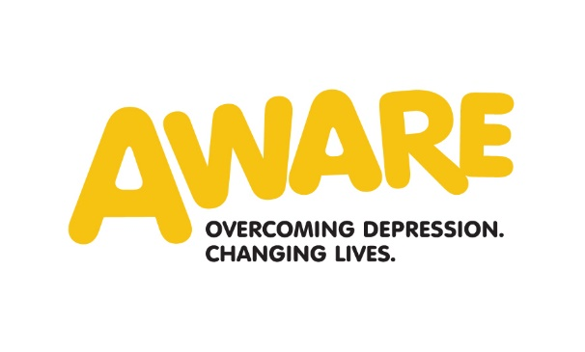
Application Form
Private and Confidential

Reference:
Position: | Corporate Fundraising Assistant
Closing Date: | 12pm Thursday 9th January 2025

Please read the accompanying Job Description and Personal Specification before completing this Application Form. All sections of the Application Form should be completed in black ink preferably in typescript or using block capitals. Application Forms received after the above closing date will not be considered.

Please note that all personal information contained on this form will be treated in strictest confidence and in compliance with the Data Protection Act 1998.

AWARE is an equal opportunity employer

Section 1 Personal Details
Surname: |  |  |  |  | Forename(s):
Address
(for correspondence) |  |  |  | Postcode:
Telephone | (am) | (pm)
Telephone | (Mobile)
Email:
Home Address
(If different from above) |  |  |  | Postcode:
Nationality: | EU Member State |  | Non EU Member State (Please specify below)
National Insurance No:

If you reach the second stage of the application process you will be invited to a formal interview at one of our offices. Will you require any special arrangements in order for us to facilitate the interview?
Section 2 Education

Secondary Education
Subject |  | Type of Examination  (GCSE, A’ Level, Leaving Cert etc.) |  |  | Year
Further Education
Subject | Qualification  (HND, NVQ etc.) |  | Examining Body | Level | Year

University Education
Subject | Type  (BA, MA, PhD etc.) | University | Class | Year

Professional Qualifications
Subject | Type | Awarding Body | Year

Do you hold membership of any professional bodies? (Please state grade of membership and year awarded)

Please outline details of any current studies

Section 3 Present Employment
Employer:
Address:
 |  | Postcode:
Telephone:
Current position held:
Date appointed to current position:
Current salary: |  | Grade:
How much notice would you be required to give if you were offered the position?

Please give details of your current employment (200 words max)

Section 4 Previous Employment

Please give details of previous posts you have held in chronological order beginning with the most recent.

Name and Address of Employer | Position/ Grade | Brief Descriptor of Duties | Dates
Name and Address of Employer | Position/ Grade | Brief Descriptor of Duties | From | To

Account here for any time since leaving school/college/university not covered by the above.
Section 5 Criteria

With reference to the personnel specification, please clearly demonstrate with appropriate examples, how you meet the following criteria:

- Qualifications (Please keep answers to 200 words max)

Educated to A-Level or equivalent or three years experience in a similar role (essential)

Educated to degree level or equivalent (desirable)

- Experience (Please keep answers to 400 words max)

1 year relevant experience (corporate relationship management, account management, sales, marketing, fundraising, business development) (Essential)

Demonstrable experience in using a range of computer packages including MS Office, particularly Word, PowerPoint and Excel (essential)

Ability to present to small groups (Desirable)

Experience working in a B2B setting (Desirable)

Experience in fundraising (Desirable)

Relationship management or customer service with donors, businesses, or volunteers (Desirable)

- Knowledge and Skills

Strong interpersonal skills and the ability to communicate well with a broad range of people, verbally and in writing. (Essential)

Please confirm that you have the following knowledge and skills
Tick as appropriate
(If shortlisted, further information may be sought at interview)
Strong written and oral communication skills and confidence to represent the organisation publicly. (Essential)
Computer literate and good knowledge of MS Office and Social Media.(Essential)
Proven ability to multi-task, prioritise and work to deadlines. (Essential)
Ability to monitor income and report to Head of Fundraising in timely manner. (Essential)
Demonstrable knowledge of the work of AWARE NI and mental health in Northern Ireland. (Essential)
Experience of designing promotional materials. (Desirable)
Working knowledge of Canva. (Desirable)
Experience using CRM systems. (Desirable)

- Personal Style & Behaviour

Please confirm that you have the following general attributes:

Tick as appropriate

(If shortlisted, further information may be sought at interview)
A flexible, inspiring and supportive colleague. (Essential)
Self-motivated with ability to work unsupervised. (Essential)
Proven team player. (Essential)
Commitment to the values of the organisation, policies & procedures & standards of conduct. (Essential)
Willing to undertake relevant on the job and external training as required. (Essential)
Commitment to the work of the organisation. (Essential)
Be open-minded, non-judgmental and have a willingness to question own attitudes. (Essential)
Able to empathise with service users regardless of race, gender, age, religion, nationality, marital status, sexual orientation or disability. (Essential)

- Other

Please confirm that you meet the following criteria.

Tick as appropriate

(If shortlisted, further information may be sought at interview)
Willingness to work flexibly including some evening and weekend work. (Essential)
Access to a car or other means of fulfilling the travel requirements of the role including business insurance. (Essential)
Willing to travel across the region and further afield including ROI, and UK if the post requires it. (Essential)

Section 6 Other Information

Provide any other information which you feel may support your application.

Section 7 References

Please name two referees who must not be relatives. At least one of your referees should have knowledge of your present work in a supervisory/managerial capacity and can be contacted for a report.

Name: |  | Name:
Position: |  | Position:
Address: |  | Address:
Postcode: |  | Postcode:
Telephone: |  | Telephone:
Email: |  | Email:
In what capacity do you know this person? |  | In what capacity do you know this person?

May we contact your references prior to interview? Yes No

Section 8 Rehabilitation of Offenders

Despite the provisions of the Rehabilitation of Offenders (Northern Ireland) Order 1978 you must, because of the nature of Health and Personal Social Services work, disclose all information concerning convictions (if any) in a Court of Law, no matter when they occurred. In the event of appointment, failure to disclose all previous convictions will result in dismissal. All information will be treated in confidence and will only be taken into account when absolutely necessary.

Recruitment of Ex-offender and Data Retention/Disposal policies are available on request.

Have you any criminal convictions? Yes No

A criminal record will not necessarily be a bar to obtaining a position with AWARE. Please disclose if there is any reason why they cannot work in regulated activity.

If yes, please give details

Section 9 Driving Licence

Do you hold a current full driving licence? | Yes No

Section 10 Holidays Arrangement

Please indicate if you have any holidays planned

Section 11 Declaration and Signature

I declare that the information in this application form, to the best of my knowledge, is true and complete. I understand that this role will be subject to both satisfactory references and where necessary a satisfactory background check by AccessNI. AccessNI Code of practice is available on request or at www.accessni.gov.uk

A candidate found to have knowingly given false information or to have wilfully suppressed material fact will be disqualified or if appointed dismissed. Only applications containing all the information sought will be considered.
To facilitate a manageable shortlist, AWARE has the right to enhance selection criteria. Only information contained on this application form will be considered at the shortlisting stage.

Canvassing either directly or indirectly will disqualify.

Usual Signature: __________________________________________________________

Date: ___________________

Please return application form by email to

Linda Wade – linda@aware-ni.org

Or by post to:

Linda Wade
AWARE
2 Crawford Square
Derry
BT48 7HR

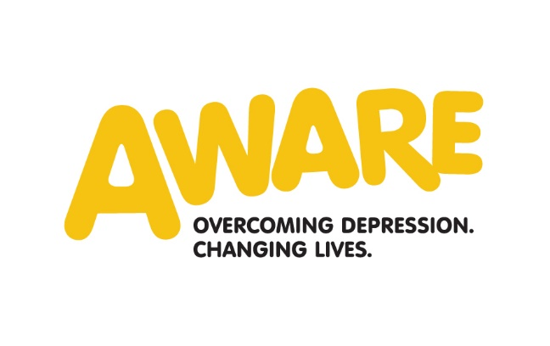
Monitoring Form
Private and Confidential

Reference: ______________

We are an Equal Opportunities Employer. We do not discriminate on grounds of religious belief or political opinion. We practice equality of opportunity in employment and select the best person for the job.

To demonstrate our commitment of equality in employment we need to monitor the community background of our applicants and employees, as required by the Fair Employment and Treatment (NI) Order 1998.

Regardless of whether we practice religion, most of us in Northern Ireland are seen as either Catholic or Protestant. We are therefore asking you to indicate your community background by ticking the appropriate box below.

I am a member of the Protestant Community
I am a member of the Roman Catholic Community
I am a member of neither the Protestant nor Roman Catholic Community
Please indicate whether you are | Male: |  | Female:

If you do not complete this questionnaire, we are encouraged to use the “residuary” method, which means that we can make a determination on the basis of personal information on file/application form.

Please note that it is a criminal offence under the legislation for a person to “give false information in connection with the preparation of the monitoring return”

