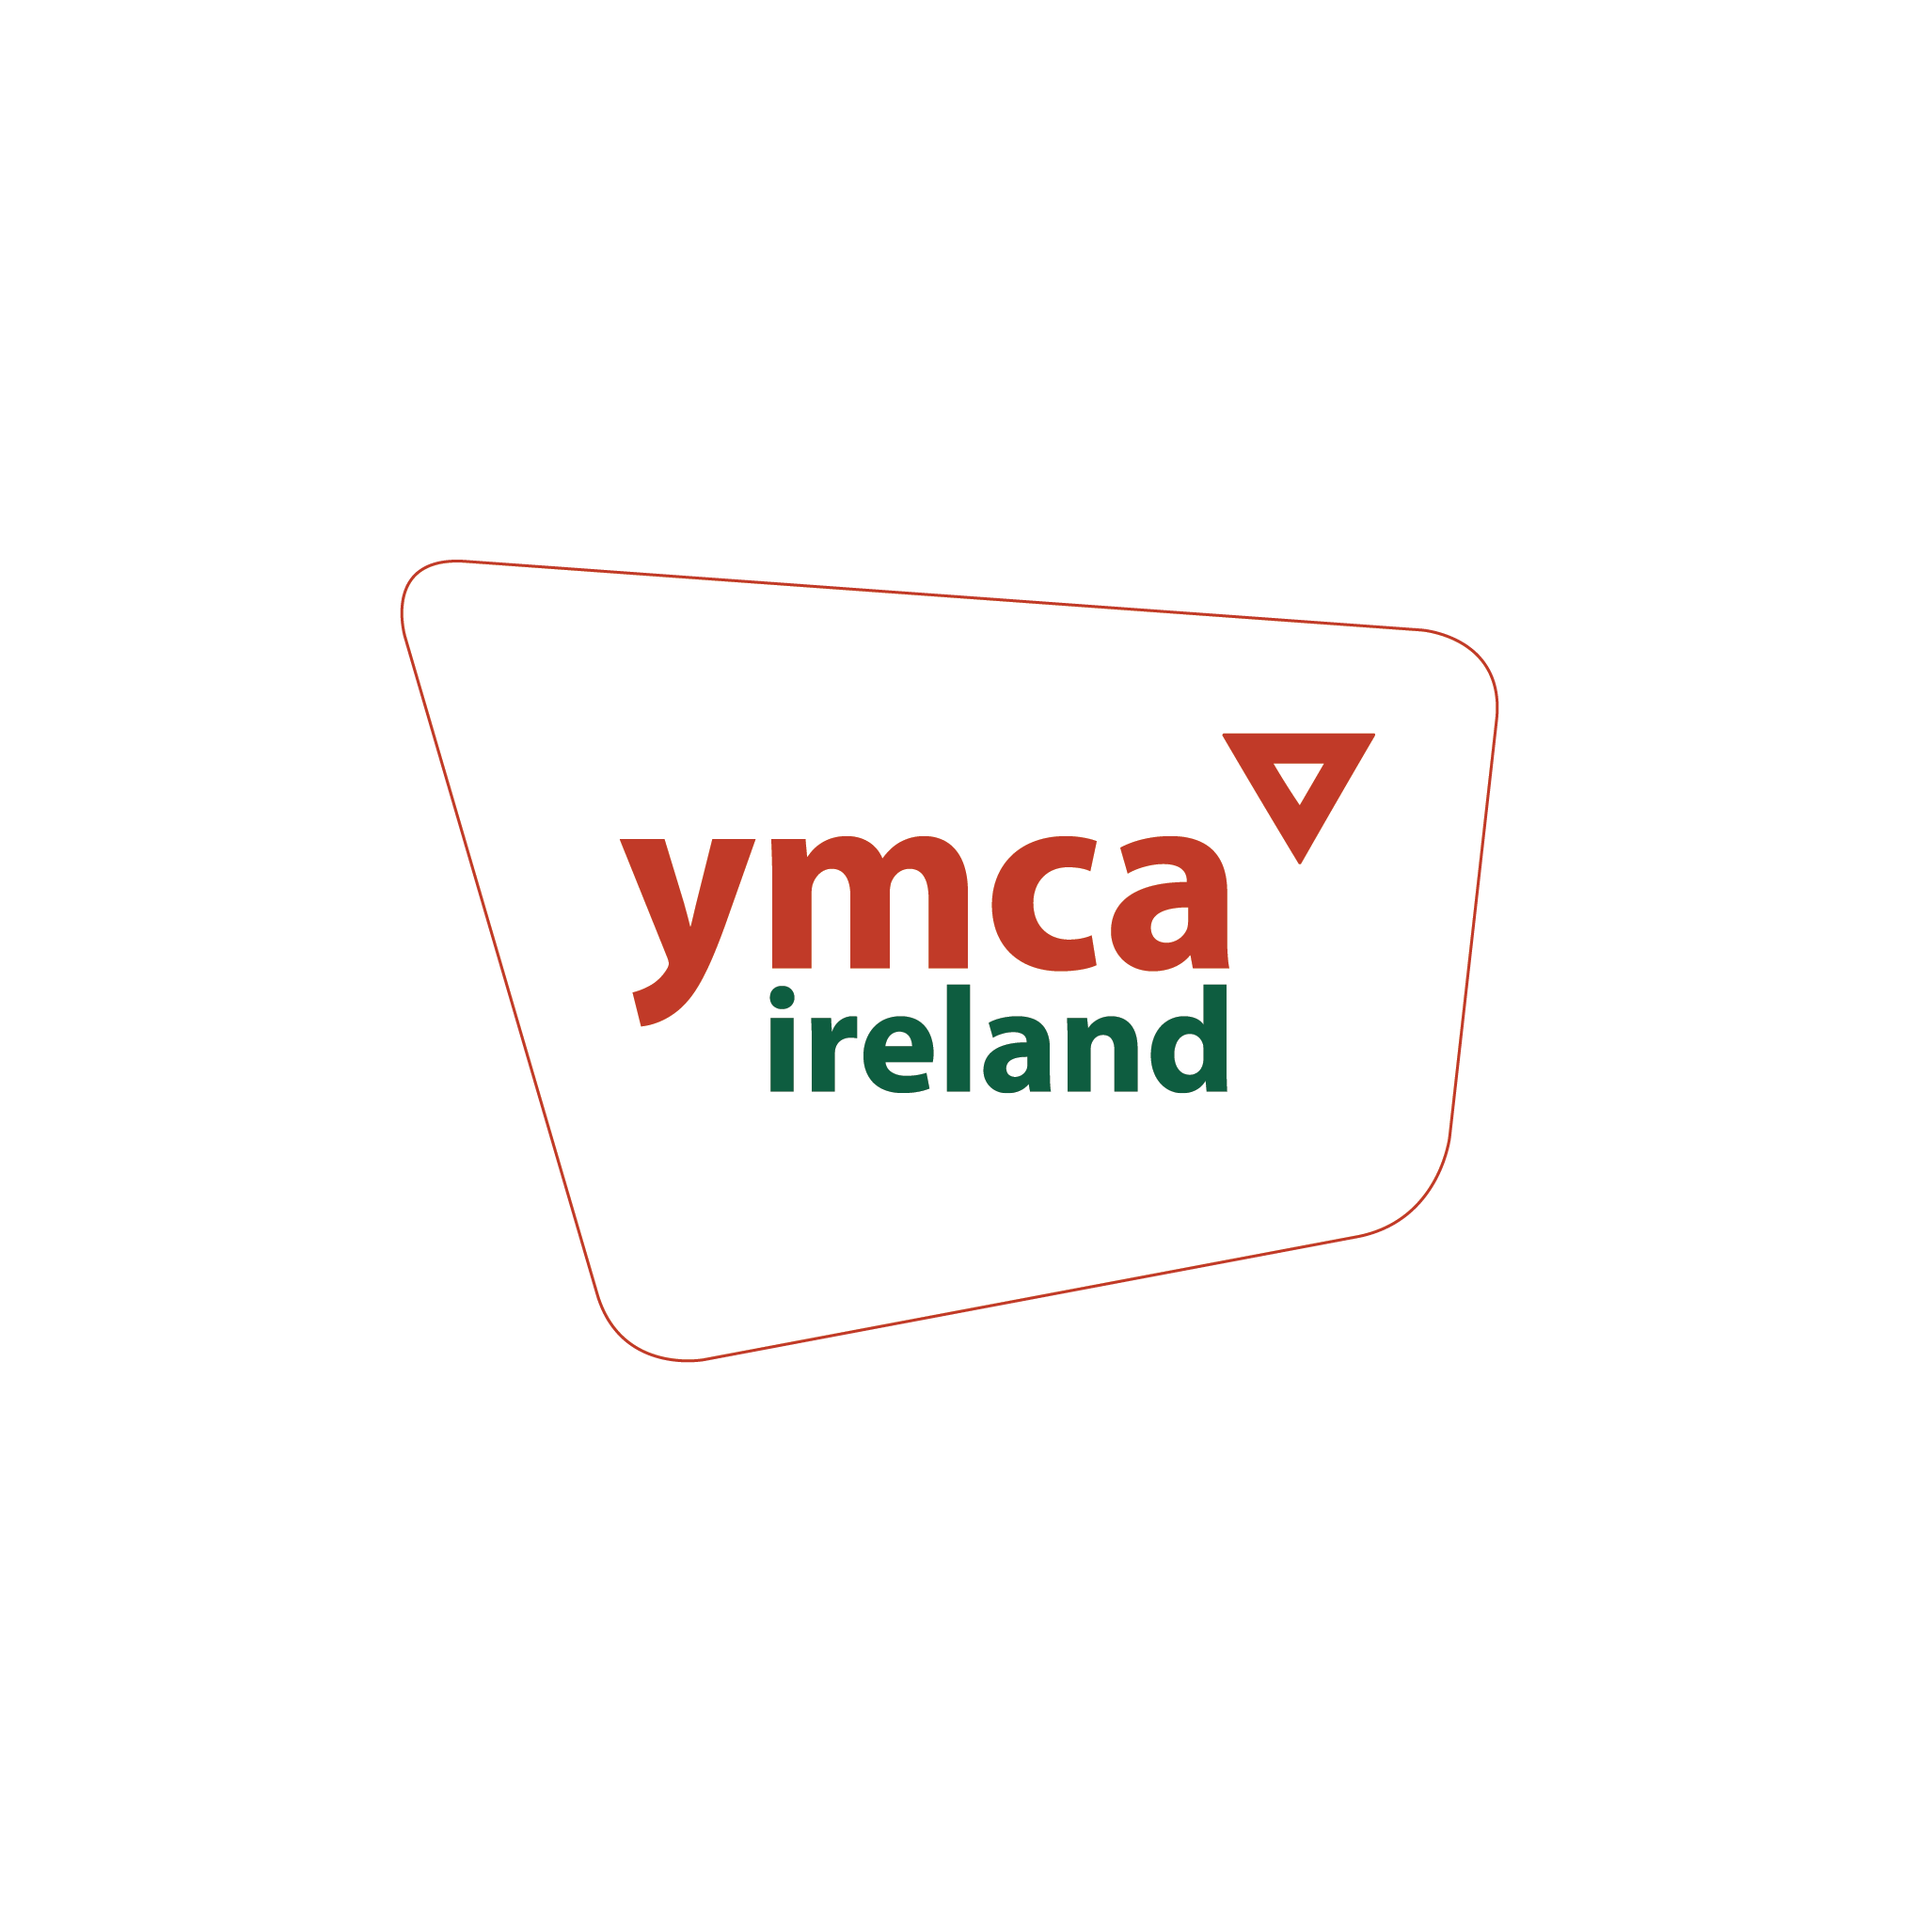

**YMCA APPLICATION FORM**

| **APPLICATION FOR THE POST OF:** | Larne YMCA - Empower 2 Transform Youth Worker |
| --- | --- |
| **APPLICANT REF. NO:** |  |
| **NAME OF APPLICANT:** |  |

Please complete this application form fully and accurately - minimum size 11 font.

**ALL DETAILS MUST BE COMPLETED ON THE APPLICATION FORM**

If there is insufficient space for your answer, continue on a separate sheet.

**When completed, this form should be emailed to:**

[**applications@ymca-ireland.net**](mailto:applications@ymca-ireland.net)

**To arrive no later than 5pm on Friday 4th April 2025**

**APPLICATION FORM**

| **PERSONAL DETAILS** |
| --- |

| **FIRST NAME** in capitals  (underline the name you are usually known by) | **SURNAME** in capitals |
| --- | --- |
| **ADDRESS:** | |
|  | |
|  | |
|  | **POST CODE:** |
| **HOME TEL NO:** | |
| **MOBILE NO:** | |
| Where did you see this vacancy advertised/How did you hear about this vacancy? | |
| **EMAIL ADDRESS:** | |
| **POSITION APPLIED FOR:** | |

| **EDUCATION**  **Please give details of all qualifications obtained along with grade and date achieved. Please give your most recent first** |
| --- |

| **Level:**  **Secondary/Further/**  **Higher** | **Dates From**  **dd/mm/yy** | **Dates**  **To**  **dd/mm/yy** | **Course Details and exam results** | **Date**  **Obtained** |
| --- | --- | --- | --- | --- |
|  |  |  |  |  |
|  |  |  |  |  |
|  |  |  |  |  |
|  |  |  |  |  |
|  |  |  |  |  |
|  |  |  |  |  |
|  |  |  |  |  |

| **PROFESSIONAL QUALIFICATIONS**  **Held or working towards** |
| --- |

| **Professional Body/**  **College/University** | **Dates**  **From**  **dd/mm/yy** | **Dates**  **To**  **dd/mm/yy** | **Course Details and results** | **Date Obtained** |
| --- | --- | --- | --- | --- |
|  |  |  |  |  |
|  |  |  |  |  |
|  |  |  |  |  |
|  |  |  |  |  |
|  |  |  |  |  |

| **SPECIALISED TRAINING** **OR COURSE ATTENDED** |
| --- |

| **Course Taken** | **Organised by** | **Location** | **Date dd/mm/yy** |
| --- | --- | --- | --- |
|  |  |  |  |
|  |  |  |  |
|  |  |  |  |
|  |  |  |  |

| **MEMBERSHIP OF PROFESSIONAL BODIES**  **Please give details of membership of any professional duties** |
| --- |

| **Name of Professional Body** | **Level / Type of Membership** | **Registration Details** | **Expiry Date** |
| --- | --- | --- | --- |
|  |  |  |  |
|  |  |  |  |
|  |  |  |  |

| **CURRENT OR MOST RECENT EMPLOYER** |
| --- |

| **Name of most recent employer** |  |
| --- | --- |
| **Address** |  |
|  |  |
|  |  |
| **Post Code** | **Tel No:** |

| **Date Started**  **dd/mm/yy** | **Date Left (if applicable)**  **dd/mm/yy** | **Reason for Leaving** | **Job Title** | **Salary** | **Notice Period (if applicable)** |
| --- | --- | --- | --- | --- | --- |
|  |  |  |  |  |  |

| **Position Held and a brief outline of duties:** |
| --- |
|  |
|  |
|  |

| **PREVIOUS EMPLOYMENT**  **Please give details of employment (paid or unpaid) over the last 10 years and begin with your most recent first** |
| --- |

| **Name and address of Employer and Nature of Business** | **Dates of Employment** | | **Position held** | **Reason for Leaving** |
| --- | --- | --- | --- | --- |
|  | **From**  **dd/mm/yy** | **To**  **dd/mm/yy** |  |  |
|  |  |  |  |  |
|  |  |  |  |  |
|  |  |  |  |  |
|  |  |  |  |  |
|  |  |  |  |  |
|  |  |  |  |  |

| **SUPPORTING INFORMATION**  **Please ensure when completing this section that you demonstrate that you meet the shortlisting criteria as set out in the job description. (Please use extra pages if needed in this section)** |
| --- |

**1. Tell us how your KNOWLEDGE meets the criteria:**

|  |
| --- |

**2. Tell us how your EXPERIENCE meets the criteria:**

|  |
| --- |

**3. Tell us how your SKILLS & ABILITIES meet the criteria:**

|  |
| --- |

| **REFERENCES**  **Please give details of 2 referees; 1 must be your current or most recent Line Manager or school/college. References from family or friends are not acceptable.** |
| --- |

| **Reference 1** | **Reference 2** |
| --- | --- |

| Name |  | Name |  |
| --- | --- | --- | --- |
| Job Title |  | Job Title |  |
| Organisation |  | Organisation |  |
| Address |  | Address |  |
| Postcode |  | Postcode |  |
| Tel No |  | Tel No |  |
| Email Address |  | Email Address |  |

YMCA Ireland is committed to safeguarding children, young people andadults at risk and to ensuring equal opportunity for all applicants. Information about criminal convictions is requested to assist the selection process and will be taken into account only when the conviction is considered materially relevant to the position applied for.

You are applying for a position that is defined as Regulated Activity under the Safeguarding Vulnerable Groups (NI) Order 2007, as amended by the Protection of Freedoms Act 2012. This post is not open to anyone who is included on the Children’s Barred List.

It also falls within the position of an ‘excepted’ position under The Rehabilitation of Offenders (Exceptions) Order (NI) 1979. This means that you must tell us about all offences and convictions, including those considered ‘spent’, which are not protected. If you leave anything out it may affect your application.

This information will be verified through an AccessNI Enhanced Disclosure Check (EDC) if you are considered to be the preferred candidate and are being offered the position. The EDC will tell us about your criminal record history (and, if the post is regulated activity, if your name has been included in a Barred List). It is to make sure that individuals who are considered a risk to children and young people are not appointed.

The information received will be treated confidentially and will be assessed alongside normal selection criteria to determine suitability for the position. A separate meeting will be held with you if clarification is required to discuss any issues around your disclosure before a final decision is reached. After the decision has been made the information will be destroyed.

Having a criminal record will not necessarily debar you from working with the YMCA. This will depend on the nature of the position, together with the circumstances and background of your offence/s or other information contained on a disclosure certificate.

Is there any reason why you cannot work in a regulated position with children and young people or adults in need of protection or at risk of harm.

Yes No

| **DECLARATION AND SIGNATURE** |
| --- |

| The information on the application form will be held and processed by the requirements of the Data Protection Act 1998 and in line with YMCA Ireland’s Data Protection Policy and Procedures.  I understand that the information is being used to:   * Process my employment application; * Form the basis of a computerised record on the recruitment system for processing and monitoring purposes; * Form the basis of a manual job file with other application forms and will be used for processing; * and if appointed, will form the basis of a manual and computerised employment record.   I declare that the information provided on this form is true and complete to the best of my knowledge. I understand that any false or omitted information may result in dismissal or other disciplinary action if I am appointed.  I agree that should I be successful in this application, I will, if required, apply for disclosure of criminal records.  I declare I have the right to work in the UK  **NOTE** The employer reserves the right to interview only candidates who meet the specified criteria. Short-listing will be based only on the information supplied by the candidate on this application form.  **Signature:** _________________________________ **Date:** ___________________  Print Name: ____________________________________________________________  **Please return this application form to:** [**applications@ymca-ireland.net**](mailto:applications@ymca-ireland.net)  **on or before: 5pm on Friday 4th April 2025**  **Please ensure you complete the Declaration and consent forms where appropriate and the Equal Opportunity Monitoring forms and return to:** [**noelle@ymca-ireland.net**](mailto:noelle@ymca-ireland.net) **on or before: 5pm on Friday 4th April 2025** |
| --- |
|  |