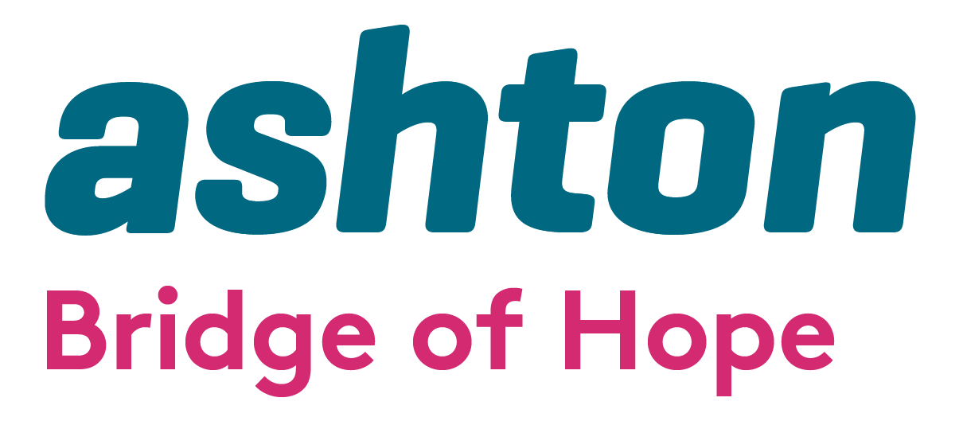

Expression of Interest in the delivery of
Personal Development & Stress Management Training and Social Isolation Programmes
2025/2025

Bridge of Hope, a project of Ashton’s Health and Wellbeing Department, is seeking expressions of interest from competent, experienced and appropriately qualified practitioners to deliver Personal Development, Stress Management and Social isolation programmes

Bridge of Hope Overview

Bridge of Hope is a health and well-being service that supports individuals affected by the conflict and those experiencing poor physical and emotional health. Our mission is “To empower and promote positive change for victims and survivors through the delivery of quality health and wellbeing services.”

Ashton Bridge of Hope holds organisational membership and is an accredited service with the British Association for Counselling and Psychotherapy (BACP), Membership Number: 211323. We operate in accordance with the BACP Ethical Framework for the Counselling Professions and ensure that all stakeholders/service users are aware of this professional code of conduct.

Our services are person-centred and based on the theory that no single approach will suit everyone. All services are monitored, and outcomes are recorded. We support people through a range of funding streams made possible by the Victims & Survivors Service, Belfast Health & Social Care Trust (BHSCT) and Public Health Agency. We are a Primary Care Talking Therapies Hub provider delivering services across the city of Belfast to meet the needs of individuals who are experiencing common mental health problems.

Holistic support services include complementary therapies: life coaching; counselling and psychological services; accredited VTCT training; personal development courses, and provide support to those applying for the Troubles Pension (TPDPS). We also provide support through our Health and Wellbeing Caseworkers. All of these services are designed to help manage and reduce stress and encourage the development of positive, healthy and resilient lives.

More details here: www.ashtoncentre.com and www.bridgeofhope.support

We currently deliver a range of personal development and stress management programmes to groups of individuals covering areas such as:

- Building resilience
- Stress management techniques
- Art Therapy
- Confidence building
- Mindfulness Practices
- Meditation
- Creative expression workshops
- Affirmation writing
- Self-discovery

Ashton, Bridge of Hope also welcomes proposals from interested individuals to deliver innovative bespoke stress management, art therapy and relaxation workshops.

If you are interested in delivering any programmes and have the associated experience, qualifications and insurance please email a copy of your proposal including a programme outline together with your CV to: -

Lindsay Whitten
Operations Manager
Bridge of Hope
Ashton Community Trust

Email: Lindsay.whitten@ashtoncentre.com

Ashton’s Bridge of Hope operates in line with the General Data Protection Regulations 2018. This means we will treat the information you provide to us with strict confidentiality. At times we may need to share some of your information with other staff, funders and other stakeholders.

START AND COMPLETION DATES
It is anticipated that funding for this service delivery will run from 1st April 2025 to 31st March 2026.

All programmes are funded by

