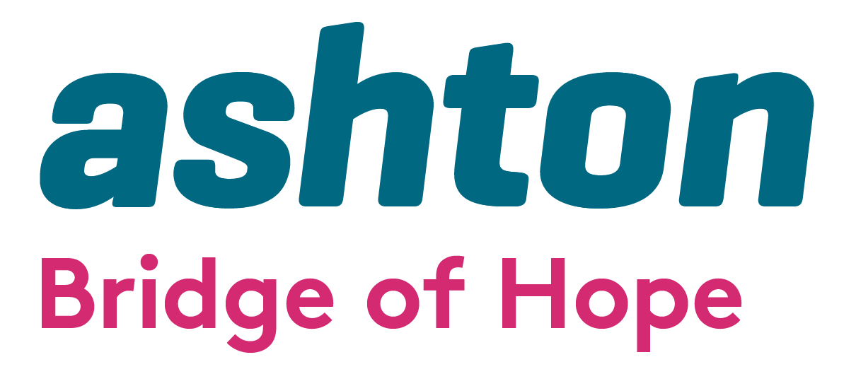

Invitation to Tender Psychological Therapies for Working with Children and Young People 2025/2026

Bridge of Hope, a project of Ashton’s Health and Wellbeing Department is inviting tender applications from ethical, competent, experienced and appropriately qualified Practitioners to deliver talking therapies on a sessional basis.

Bridge of Hope Overview

Bridge of Hope is a health and wellbeing service that supports individuals affected by the conflict and those experiencing poor physical and emotional health. Our mission is “To empower and promote positive change for victims and survivors through delivery of quality health and wellbeing services.”

Ashton Bridge of Hope holds organisational membership and is an accredited service with the British Association for Counselling and Psychotherapy, (BACP), Membership Number: 211323. We operate in accordance with the BACP Ethical Framework for the Counselling Professions and ensure that all stakeholders/service users are aware of this professional code of conduct.

Our services are person centred and based on the theory that no single approach will suit everyone. All services are monitored and outcomes recorded. We support people through a range of funding streams made possible by the Victims & Survivors Service, Belfast Health & Social Care Trust (BHSCT) and Public Health Agency. We are a Primary Care Talking Therapies Hub provider delivering services across the city of Belfast to meet the needs of individuals who are experiencing common mental health problems.

Holistic support services include: complementary therapies; physiotherapy; life coaching; counselling and psychological services; accredited VTCT training; personal development courses and conflict legacy programmes. We also provide support through PEACE IV Health and Wellbeing Caseworkers. All of these services are designed to help manage and reduce stress and encourage the development of positive, healthy and resilient lives.

More details here: www.ashtoncentre.com and www.bridgeofhope.support



Role description

We see this role to have a range of priorities:

- To work with Children and Young People on a one-to-one basis, To provide one-to-one psychological therapy to Children and Young People experiencing common mental health problems.
- To have an ongoing commitment to clinical supervision monthly with a Clinical Supervisor who is experienced in working online and telephone, including annual clinical supervision reporting.
- To act as a liaison for other Bridge of Hope staff.
- To travel to any Bridge of Hope outreach centre as required.
- To inform Children and Young People about the range of support services offered by Bridge of Hope to encourage a holistic approach.
- To work closely with identified Bridge of Hope staff to ensure that all appropriate procedures and processes are followed at all times.
- To be a critical point of contact for Children and Young People presenting in crisis.
- Attend quarterly meetings with the Clinical Lead and/or other relevant Bridge of Hope, Ashton staff throughout the year.
- Liaise with Bridge of Hope Clinical Lead immediately should a problem arise relating to the well-being of any individual and/or if identified that an individual requires any other support or referral pathway.
- Attend an annual appraisal meeting with the Clinical Lead
- Demonstrate commitment to CPD and maintain an annual CPD Log.
- Ensure all processes (including CORENet and GP letters) are completed accurately and kept up to date and that any other required paperwork is returned to the Clinical Lead at Bridge of Hope fully completed and on time.
- Be prepared to deliver a flexible service for Bridge of Hope to enable us to meet the needs of our client base.

The tender format is as follows:

- Applicants must demonstrate and provide evidence where appropriate how they meet all elements of the essential criteria. Please note it is important to address each criterion listed above in your application. Failure to do so will result in your tender application being deemed ineligible.
- Applicants must include a full and up to date CV with their application.
- Applicants must include a copy of all relevant certificates.
- Applicants must include evidence of membership of BACP or equivalent body prior to commencement of sub-contracting.
- Applicants must include evidence of Professional Liability Insurance to a minimum of £5 million.
- Applicants must outline what days and times they are available to deliver services on behalf of Bridge of Hope. Please be aware Bridge of Hope deliver sessions both during the day and some evenings.
- Tender applications must include a completed Declaration of Employment Status form.

Copies of tender proposals should be forwarded, by email with “Tender for psychological therapies for Children and Young People” in the subject line to: lindsay.whitten@ashtoncentre.com.

Any tender applications not including all information required above will be discounted as incomplete and will not move to scoring.

All tenders must be received no later than 12.00 pm on Monday 24th March 2025. No late tenders will be accepted. Where appropriate, interviews will be held as soon as possible after this date.

Bridge of Hope will use the information supplied to score all tender applications. Please take note of scoring criteria as this will be used to total scores, and only applicants who score over 80 will be added to our Approved Suppliers List.

A score of 80 or more will enable an applicant’s details to be added to our Approved Suppliers List.

Please note being added to the Approved Suppliers List does not constitute any guarantee of sessional hours.

Any successful tender will be valid from 1st April 2025 to 31st March 2026.

Ashton’s Bridge of Hope operates in accordance with the General Data Protection Regulations 2018. This means we will treat the information you provide with strict confidentiality. At times we may need to share some of your information with other staff, funders and other stakeholders.

Award Criteria | Score out of 100
Demonstration of 2 years post-qualifying practice (with no less than 300 hours post-qualifying practice)  AND  Accredited Member of BACP/IACP/NCS or equivalent, please include your number.  OR  Actively working towards accreditation with an understanding that this will be achieved within 24 months of starting client work with Ashton. | 25
Qualification in Counselling children and young people, (Minimum Level 5 Diploma) | 15
Knowledge of the Step Care Model and work with individuals experiencing common mental health problems | 12
Demonstration of Trauma Training and experience of working with Victims and Survivors | 12
Commitment to receiving regular clinical supervision | 5
Commitment to CPD | 5
Demonstration of qualifications | 4
Keeping Children Safe Training (completed within the last 2 years) | 5
Keeping Adults Safe / Safeguarding Adults Training (completed within the last 2 years) | 5
Demonstration of Value for Money | 3
Evidence of Professional Insurance | 3
CV included | 3
Availability for delivery of sessions | 3
Contact Details: If you require further information, wish to clarify any points or have difficulty relating to the tender documentation before submission of your proposal please contact the Operations Manager, Lindsay Whitten via email lindsay.whitten@ashtoncentre.com or phone on 028 9074 2255.

START AND COMPLETION DATES

It is anticipated that funding for this service delivery will be until 31st March 2026.
Invitation to Tender Psychological Therapies for Working with Children and Young People 2025/2026

NAME: _________________________ TELEPHONE: __________________

EMAIL: ________________________________________ DATE: _____________

Essential Criteria
Demonstration of 2 years post-qualifying practice (with no less than 300 hours post-qualifying practice)

AND

Accredited Member of BACP/IACP/NCS, or equivalent, please include your number.

OR

Actively working towards accreditation with an understanding that this will be achieved within 24 months of starting client work with Ashton.

2. Qualification in Counselling children and young people, (Minimum Level 5 Diploma)

3. Please demonstrate your knowledge of the Step Care Model and issues presented by Children & Young People.

4. Please demonstrate your understanding of Conflict Trauma & its Transgenerational Impact.

5. Please give Supervisors details including regularity of appointments.

6. Please state qualifications and outline knowledge of the Children’s Act & legislation pertaining to children.

7. Have you completed Keeping Children Safe Training within the last 2 years? If so please detail dates of completion and include a copy of your certificate with your tender.

8. Have you completed Keeping Adults Safe Training within the last 2 years? If so please detail dates of completion and include a copy of your certificate with
your tender.

9. Please demonstrate your commitment to continuing professional development.

10. Have you completed Mental Health First Aid (or equivalent)? If so please detail dates of completion and include a copy of your certificate with your tender.

11. Outline days and times available for delivery of sessions.

Check List for Applicants

CV
Professional Liability Insurance
Certificates of Qualifications
Keeping Adults Safe / Safeguarding Adults Certificate
Keeping Children Safe Certificate
Membership of BACP or Equivalent Body

